**Processing T1 Nifti Files for TMS Simulations in SimNIBS and Converting Output to FreeSurfer Format**

**Objective:** To standardize the procedure for converting T1 Nifti files to CHARM format, running TMS simulations using specified coordinates in SimNIBS on a Macintosh system, and converting the output .msh files to FreeSurfer files using a MATLAB script.

**Materials:**

1. Software: SimNIBS 4.0, FreeSurfer.
2. T1 weighted MRI data in NIFTI format
3. Coordinate of simulation position (In X Y Z. Note: F3 On the standard model is roughly -45, 80, 60)

**Getting Started:** [**https://simnibs.github.io/simnibs/build/html/tutorial/tutorial.html**](https://simnibs.github.io/simnibs/build/html/tutorial/tutorial.html)

**Procedure:**

Converting Nifti Files to CHARM Format:

1. Open Terminal on the Mac.
2. Navigate to the directory containing the Nifti files.
3. Open Command Window
4. Use the following command to convert Nifti to CHARMM format (replace your_nifti_file.nii with the actual file name):

*charm your_subject_id your_nifti_file.nii*

For us it was:

*charm –forceqform P1 /Users/sara/Desktop/PUSH1_T1s/P1.nii*

For a looped version of this:

*diff=/Users/sara/Desktop/PUSH1_T1s/*

*cd $diff*

*for patient in *.nii;*

*do*

*charm —forceqform $patient $patient.nii*

*done*

1. Verify the output files are correctly generated in the specified output directory.

(Charm as it appears on windows cmd. Modify the settings for your use, or just use charm N1 with the associated .nii files and run)

Once CHARM completes, you will have a m2m_ file folder in your directory. The Charm conversion can take a while (~30 min) to complete and is computationally expensive.

Loading m2m_ files into SimNIBS 4.0 and Running simulations.

1. Open the SimNIBS GUI or prepare a simulation script specifying:

* Select the subject’s m2m folder.
* Rename the output folder to include the subject ID
  + Example: P101_simnibs_simulation
* Click “Add TMSPoslist”
* For coil definition file select MagVenture Cool B65
  + ﻿/Users/sara/Applications/SimNIBS-4.0/simnibs_env/lib/python3.9/site-packages/simnibs/resources/coil_models/Drakaki_BrainStim_2022/MagVenture_Cool-B65.ccd
  + 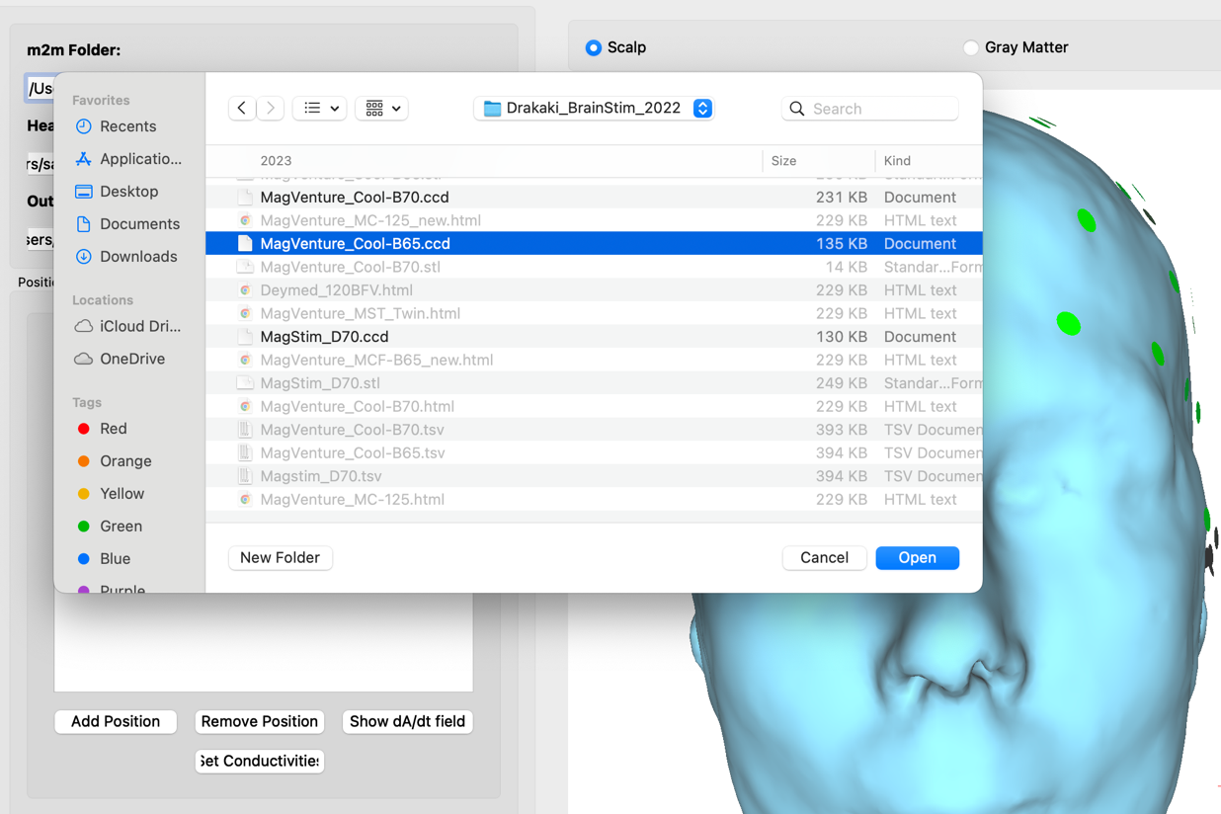
* Click “Add Position”
* Set “dl/dt” to ﻿75x1e6 A/s
* Click within the empty section in the position column
* Select position “F3” (xyz coordinates may vary since this is mapped to subject specific space) and click “Ok”
  + 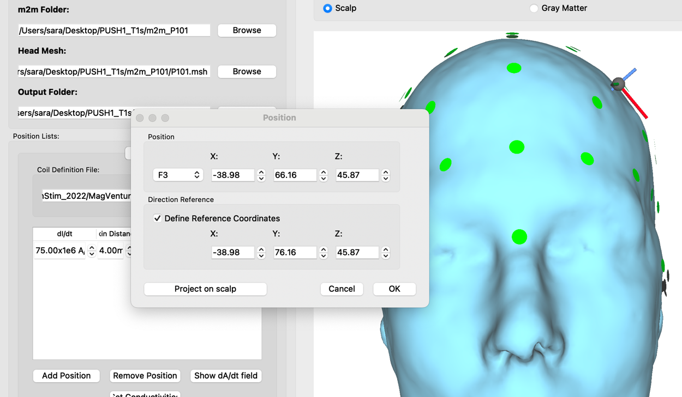
* Open Stimulation options
  + 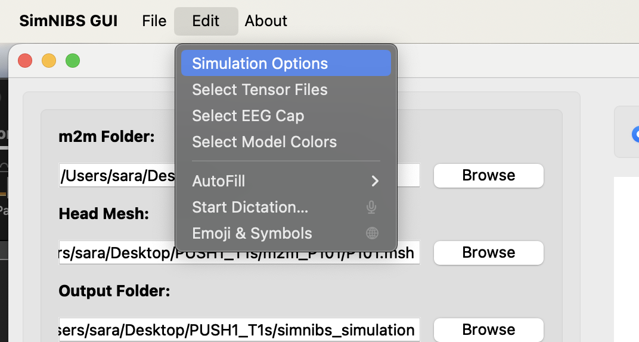
* Set the options as shown and then click “ok”
  + 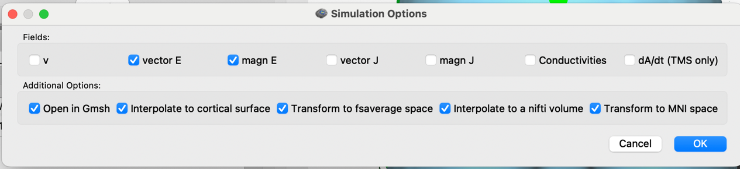
* Click “run” at the bottom left of the window
* Review visualizations for accuracy
  + 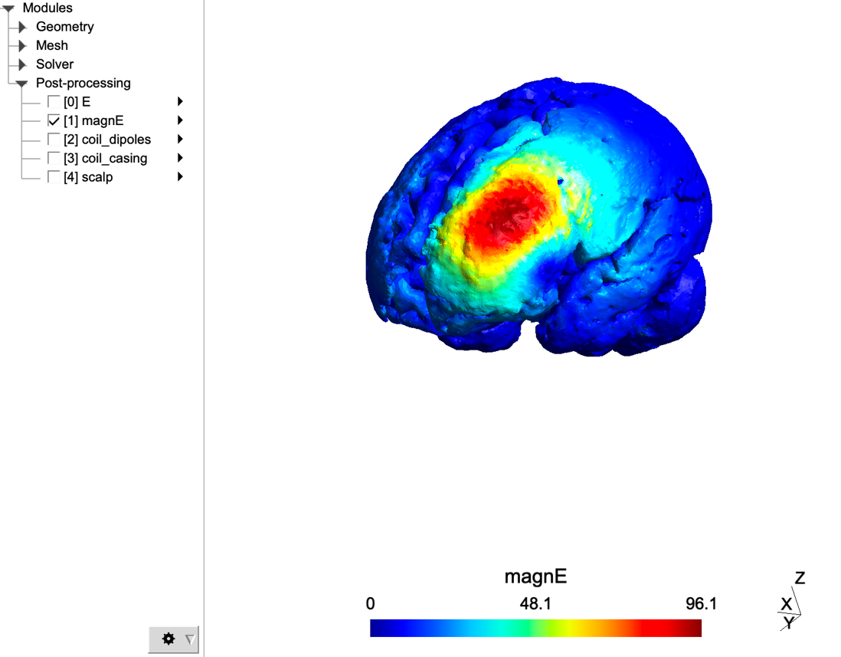

If needed there is also a general tutorial on how to set up simulations via this link:

[Setting up and Running Simulations — SimNIBS g75fd674e') documentation](https://simnibs.github.io/simnibs/build/html/tutorial/gui.html)

Conversion of FreeSurfer files

* Simnibs automatically outputs in fsaverage space. However, this will need to be converted to updated fsaverage spaces such as fsaverage6.

Or read through the SimNibs documentation on how to analyze simulation results using MATLAB and Python:

[Analyzing Simulations — SimNIBS g75fd674e') documentation](https://simnibs.github.io/simnibs/build/html/tutorial/analysis.html)

For example, running an MNI ROI in MATLAB:

% Simple ROI analysis of the electric field from a simulation.

% We will calculate the mean electric field in a gray matter ROI

% The ROI is defined using an MNI coordinates

%% Load Simulation Result

% Read the simulation result

head_mesh = mesh_load_gmsh4(...

fullfile('tdcs_simu', 'ernie_TDCS_1_scalar.msh') ...

);

% Crop the mesh so we only have gray matter volume elements (tag 2 in the mesh)

gray_matter = mesh_extract_regions(head_mesh, 'region_idx', 2);

%% Define the ROI

% Define M1 from MNI coordinates (https://www.ncbi.nlm.nih.gov/pmc/articles/PMC2034289/)

% the first argument is the MNI coordinates

% the second argument is the subject "m2m" folder

ernie_coords = mni2subject_coords([-37, -21, 58], fullfile(pwd, 'm2m_ernie'));

% we will use a sphere of radius 10 mm

r = 10;

% Electric fields are defined in the center of the elements

% get element centers

elm_centers = mesh_get_tetrahedron_centers(gray_matter);

% determine the elements in the ROI

roi = sqrt(sum(bsxfun(@minus, elm_centers, ernie_coords).^2, 2)) < r;

% get element volumes, we will use those for averaging

elm_vols = mesh_get_tetrahedron_sizes(gray_matter);

%% Get field and calculate the mean

% Get the field of interest

field_name = 'magnE';

field_idx = get_field_idx(gray_matter, field_name, 'elements');

field = gray_matter.element_data{field_idx}.tetdata;

% Calculate the mean

avg_field_roi = sum(field(roi) .* elm_vols(roi))/sum(elm_vols(roi));

fprintf('mean %s in ROI: %f\n', field_name, avg_field_roi)